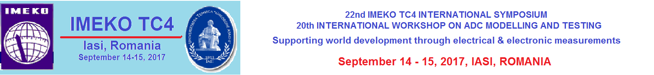

COPYRIGHT FORM*

Paper ID
Paper title
Authors’ names
Affiliation

Declaration

I agree that the manuscript of my paper presented at the joint event 22nd IMEKO TC4 International Symposium and 20th International Workshop on ADC Modelling and Testing be published in the following electronic versions: event web page, IMEKO web page, and in digital media distributed to event attendees.
The owner of the copyright is the International Measurement Confederation.
I agree that no honorarium is due.
I confirm that the contents of my paper have not been, or will not be submitted elsewhere for publication in substantially the same form without the written permission of IMEKO.
I also give my permission to IMEKO to use my address and other contact information in the Scientific Contact Service and to forward my address to Institutes and Companies wishing to contact me as an expert. My expertise area is indicated by the keywords I have given in my paper.

Do not use my address for commercial mailing: ……… (tick here if appropriate).

Date: Signature of the corresponding author

………………………. ……………………………………………

* Please fill out this document for every paper submitted to the symposium, sign it and attach a scanned copy (pdf, only one file for all papers) in the registration interface.

